**Project Design Phase-II Technology Stack (Architecture & Stack)**

|  |  |
| --- | --- |
| Date | 28 October 2022 |
| Team ID | PNT2022TMID11899 |
| Project Name | Project - Inventory management system for retailers |
| Maximum Marks | 4 Marks |

**Technical Architecture:**

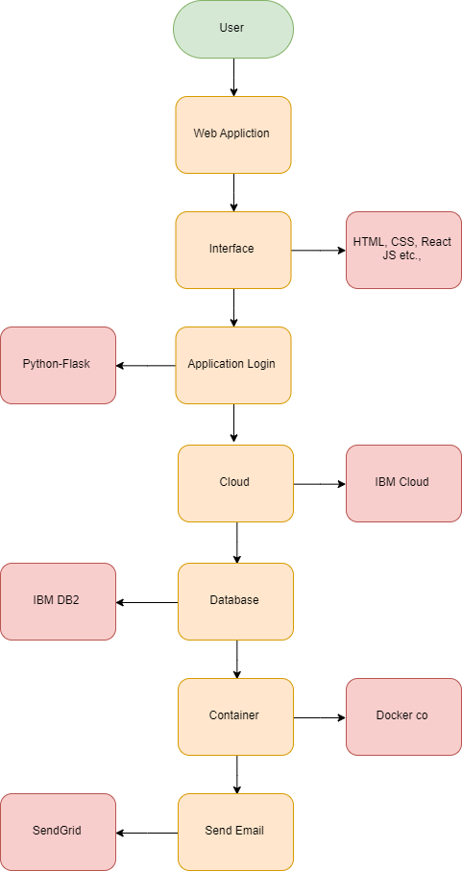

Table-1 : Components & Technologies:

|  |  |  |  |
| --- | --- | --- | --- |
| **S.No** | **Component** | **Description** | **Technology** |
| 1. | User Interface | How user interacts with application e.g. Web UI, Mobile App, Chatbot etc. | HTML, CSS, JavaScript / Angular Js / React Js etc. |
| 2. | Application Logic | Logic for a process in the application | Python-Flask |
| 3. | Database | Data Type, Configurations etc. | MySQL, NoSQL, etc. |
| 4. | Cloud Database | Database Service on Cloud | IBM DB2 |
| 5. | File Storage | File storage requirements | IBM Cloud Object Storage |
| 6. | App Container | Contain the whole application in a single container | Docker Container / IBM Container Registry |
| 7. | Infrastructure (Server / Cloud) | Application Deployment on Local System / Cloud  Local Server Configuration: Cloud Server Configuration: | Local, Cloud Foundry, Kubernetes, etc. |
| 8. | Send Mails | Sending mails about stocks available in the Inventory to the Retailer | SendGrid |

Table-2: Application Characteristics:

|  |  |  |  |
| --- | --- | --- | --- |
| **S.No** | **Characteristics** | **Description** | **Technology** |
| 1. | Open-Source Frameworks | List the open-source frameworks used | React Js / Flask |
| 2. | Security Implementations | List all the security / access controls implemented, use of firewalls etc. | IBM Cloud Security |
| 3. | Availability | Justify the availability of application (e.g., use of load balancers, distributed servers etc.) | Python-Flask |